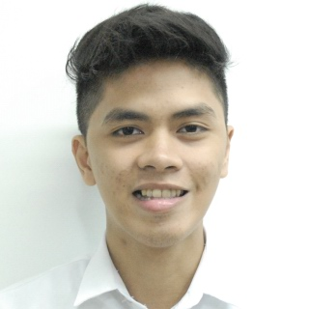**CABALLERO, RUSSEL ROBERT B.**

#29 East Riverside St.

San Francisco Del Monte Quezon City

Email: caballerorusselrobert@gmail.com

Mobile Number: 09156775331

**CAREER OBJECTIVES**

* Develop IT skills with collaboration with others in achieving organization’s goals;
* Work independently and be a part of a team;
* Organize, prioritize, manage time, and apply skills in software development.

**SYSTEM DEVELOPMENT EXPERIENCE**

* Designed a webpage project on HTML CS111L.
* Adept in using MS Office products (PowerPoint, Word, Access, Excel); Adobe Photoshop.

**EDUCATION**

**BS in Computer Science**

June 2013- present

         New Era University

**PERSONAL INFORMATION**

Date of Birth :  May 23, 1995

Place of Birth      :  Fairview General Hospital

Age                :  19 years old

Civil Status         :  Single

Height                :  5’8

Weight            :  57 kg

Citizenship          :  Filipino